**2026 Revision of Blue Book Categories: FAQs for Design Consultants**

*Why is KDOT changing the pre-qualification categories in the Blue Book?*

Over the past two years, KDOT has assessed how often our pre-qualification categories are used in RFPs and what qualifications are required for each category. With this information, we have identified: sixteen categories that are not frequently used and will remove them; six categories for which updated requirements are necessary; and three new categories that will be added. These changes will better align our pre-qualification categories with KDOT’s current consultant support needs. At the same time, the overall reduction in categories will reduce the workload for consultants preparing pre-qualification packages and for KDOT staff reviewing them.

*What categories are changing in the new Blue Book?*

The following is a summary of changes to the Blue Book categories. The full text of the updated Blue Book is available [here](https://ikewebstorage.blob.core.windows.net/files/KDOT-Blue-Book-2026-Ed-Rv1.pdf).

*A category that my firm is pre-qualified in is being removed from the Blue Book. Does this mean KDOT will no longer solicit services in this category?*

The categories that are being removed from the Blue Book are those that KDOT has used infrequently in recent years. However, KDOT may still need to solicit these types of services from time to time. When such a need arises, the RFP will be accessible to all firms and will require that interested firms submit their qualifications for the subject type of work with their proposal. The RFP language will clearly state the qualification requirements and what consultants must include in their proposal to show their qualifications. In some cases, an RFI may be used to solicit an on-call service request. In these cases, the RFI will only be solicited to on-call master agreement holders and will clearly state requirements and information requested.

*What is the timeline for implementation of the new Blue Book?*

The updated Blue Book will be fully implemented in January 2026. However, firms will use their 2025 pre-qualification quarter to prepare for the 2026 roll-out. KDOT will stop using the categories that are being removed in 2026 before the first quarter firms resubmit their pre-qualification packages in 2025. See the graphic below for an illustration of the implementation timeline.

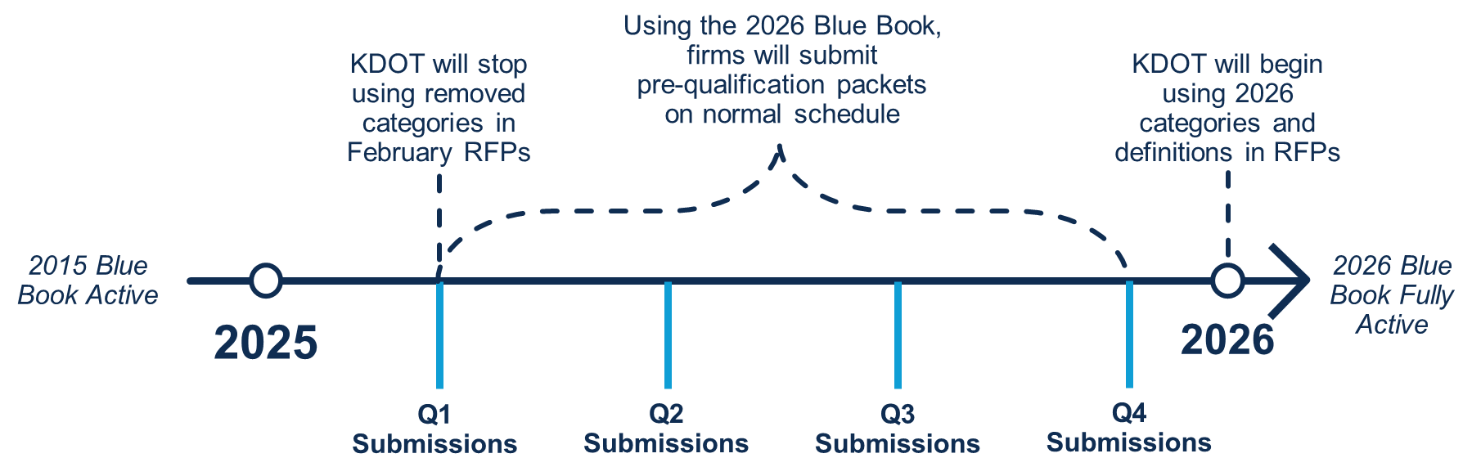

*How do I ensure I’m properly pre-qualified for RFPs coming out in 2025, during the transition?*

During 2025, firms will remain pre-qualified in all categories for they achieved such status with their 2024 submittals until their normal, quarterly expiration dates.

Additionally, once a firm submits its pre-qualification package in 2025 using the [2026 Blue Book](https://ikewebstorage.blob.core.windows.net/files/KDOT-Blue-Book-2026-Ed-Rv1.pdf) requirements, it will be considered pre-qualified for the categories in which KDOT reviewers deem them approved for the remainder of 2025 and until they expire in 2026. This is because the new requirements in the six changing categories meet or exceed the existing requirements.

If you have additional questions, please contact [KDOT.DesignContracts@ks.gov](mailto:KDOT.DesignContracts@ks.gov).

*Does my firm need to submit a full pre-qualification package in 2025?*

The following decision tree will help you determine if you need to submit a full pre-qualification package during your 2025 submission period.

*Will this change impact when I submit a pre-qualification package?*

Firms will continue to submit pre-qualification packets in their regular quarter. Any firm which has never been pre-qualified with KDOT (or whose status has expired more than a year ago) is welcome to submit a pre-qualification package at its convenience.

All submissions must be full pre-qualification packages in 2025. No partial submissions are accepted.

*Is the pre-qualification package submission process changing?*

No, the overall process remains unchanged. However, the [1050 Form](https://view.officeapps.live.com/op/view.aspx?src=https%3A%2F%2Fikewebstorage.blob.core.windows.net%2Ffiles%2FKDOT-Consultant-Qualification-Form.docx&wdOrigin=BROWSELINK) used to submit pre-qualifications has been updated to reflect the new categories as well as other changes requested by category reviewers. Most changes are minor and require firms to fill out fewer fields. Please ensure you use the updated form when submitting your pre-qualification package in 2025 and beyond. Previous versions of the form will not be reviewed.

*When is my firm due to resubmit our pre-qualification package?*

Please email [KDOT.DesignContacts@ks.gov](mailto:KDOT.DesignContacts@ks.gov) to find the quarter in which your firm should submit a pre-qualification package.

*Does this change to the Blue Book change the review process?*

No, KDOT’s process for reviewing pre-qualification submissions will remain the same.

*Who should I contact if I have additional questions about specific pre-qualification requirements or about the submittal and review process?*

Please email [KDOT.DesignContacts@ks.gov](mailto:KDOT.DesignContacts@ks.gov) with any questions about category requirements or the pre-qualification process.